1. Write a thread program to do the following. Let thread performs summation of cat1 and cat2 mark of a student and return the sum to the main function. Display the name and sum of cat1 and cat2 mark in main().

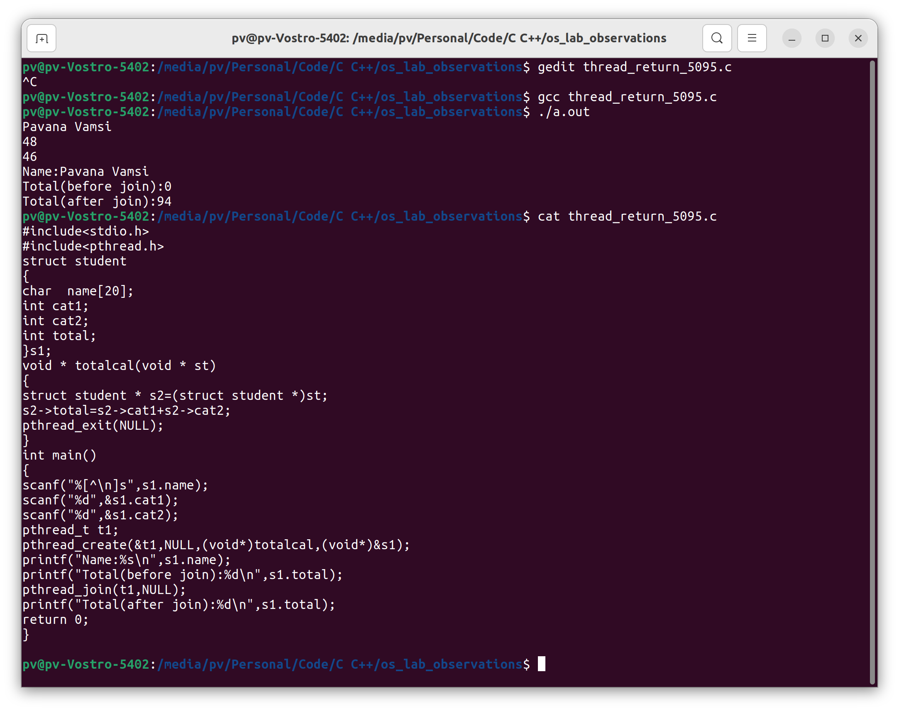

1. 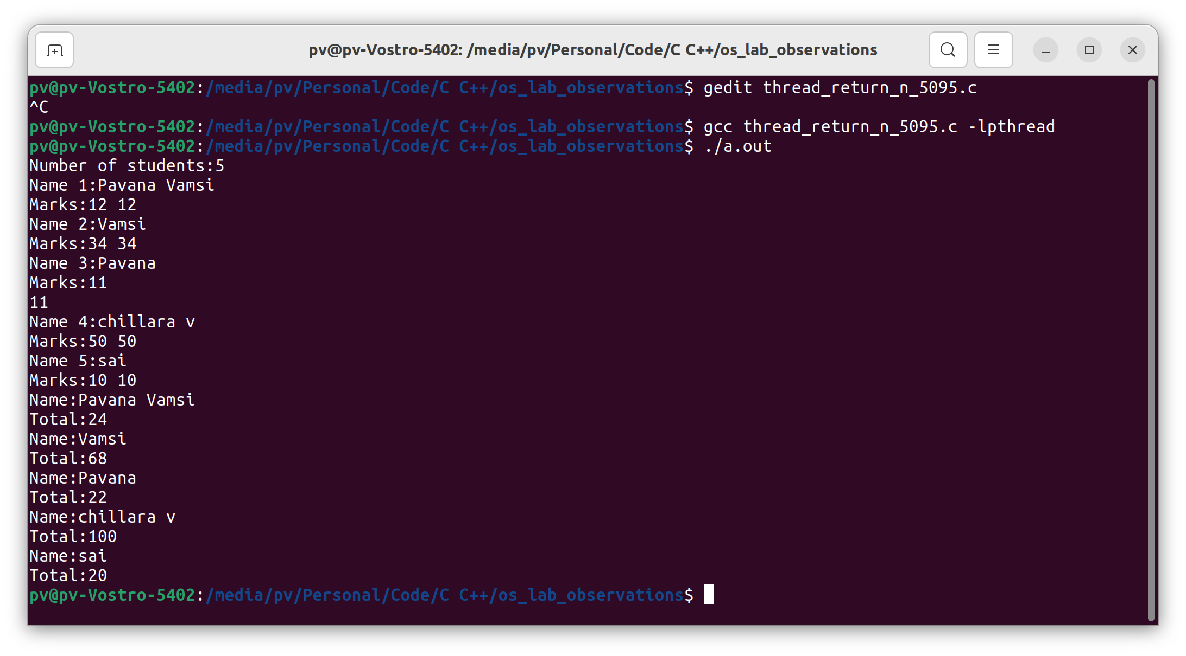Implement the question 1 for array of 5 students.

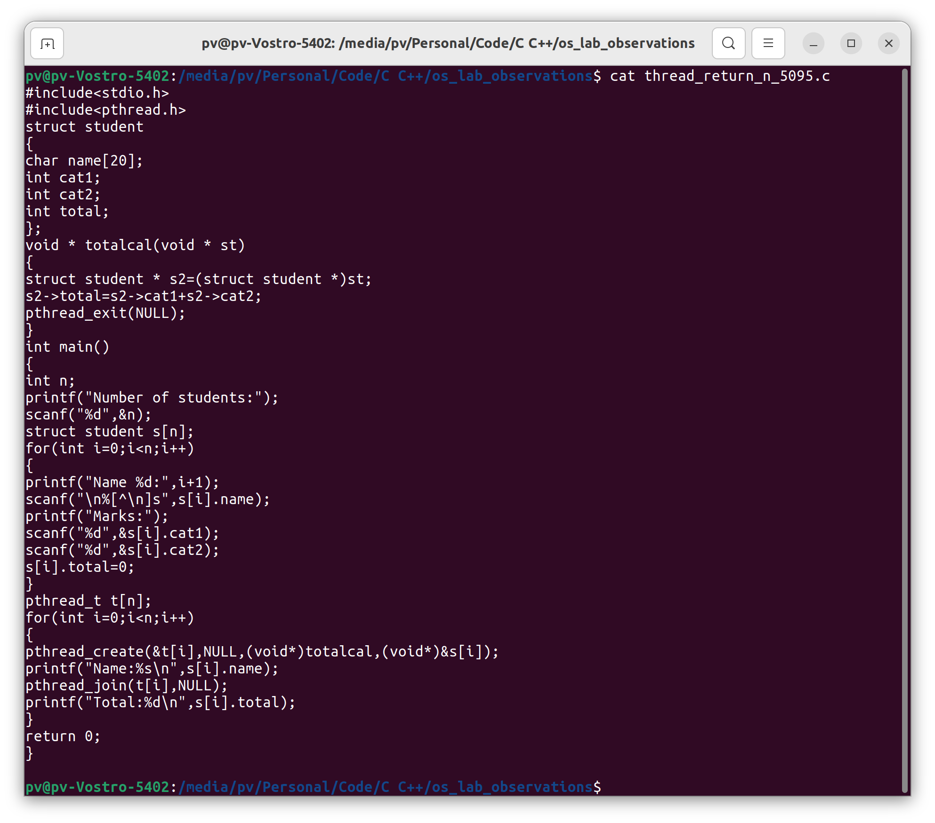

1. Implement CAT1 - thread, process questions

Hierarchy process creation. Creating a new child process from main and creating the tree using for loops.

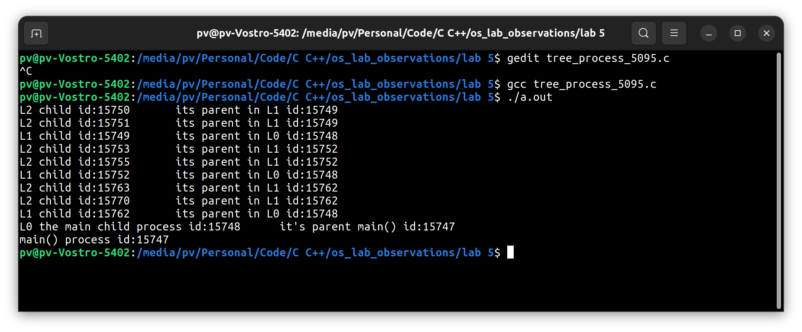

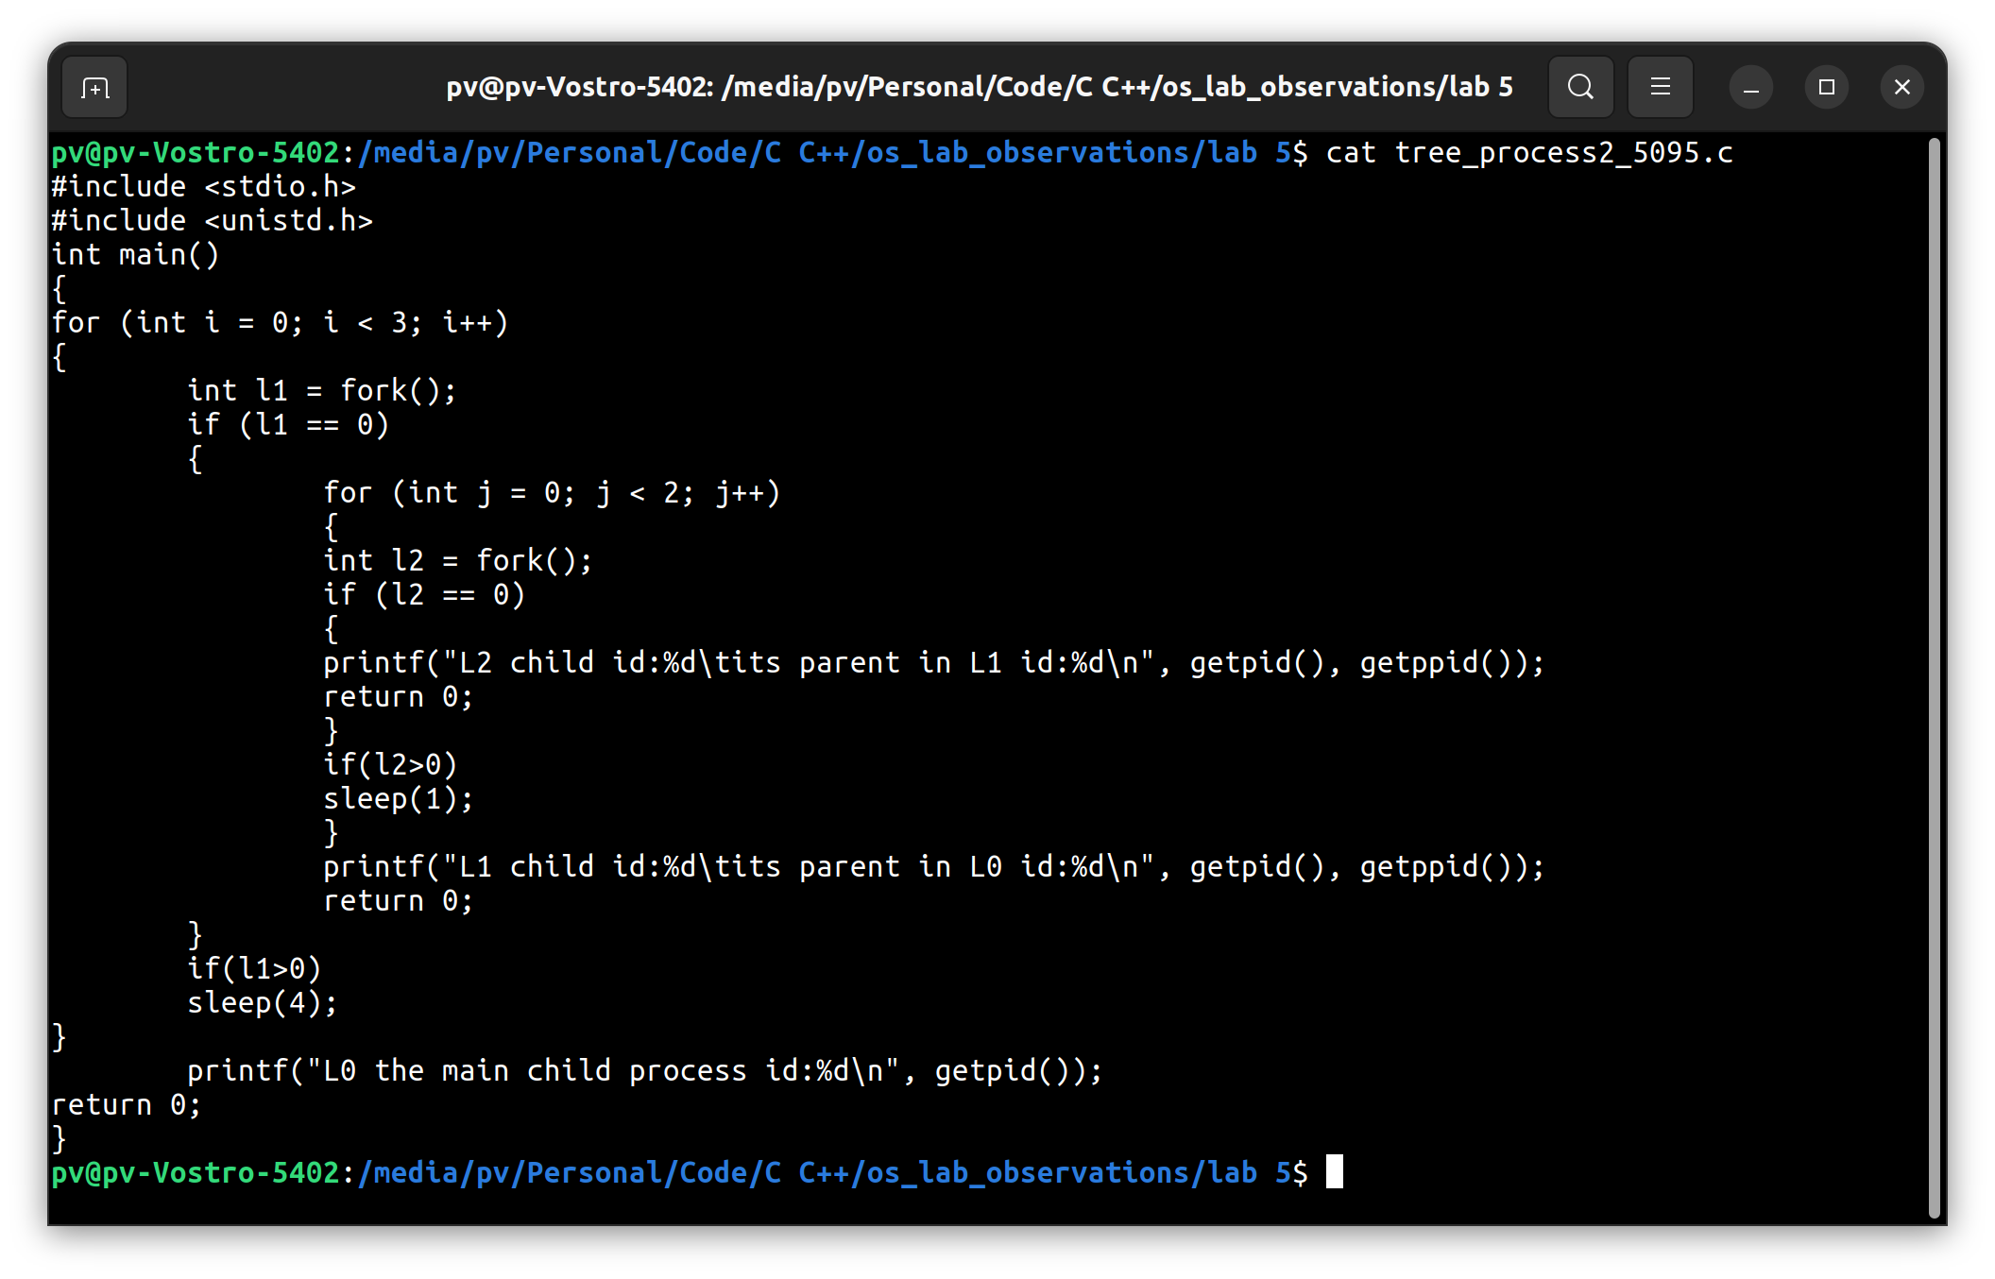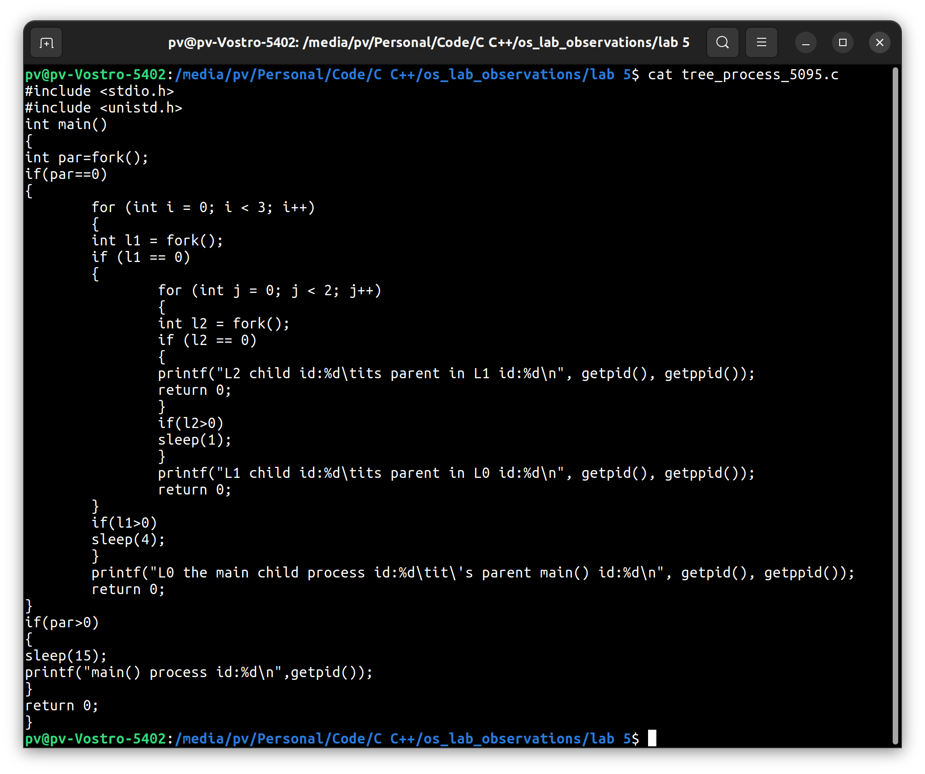 Hierarchy process creation. Assuming as created process and proceeding the child creation.

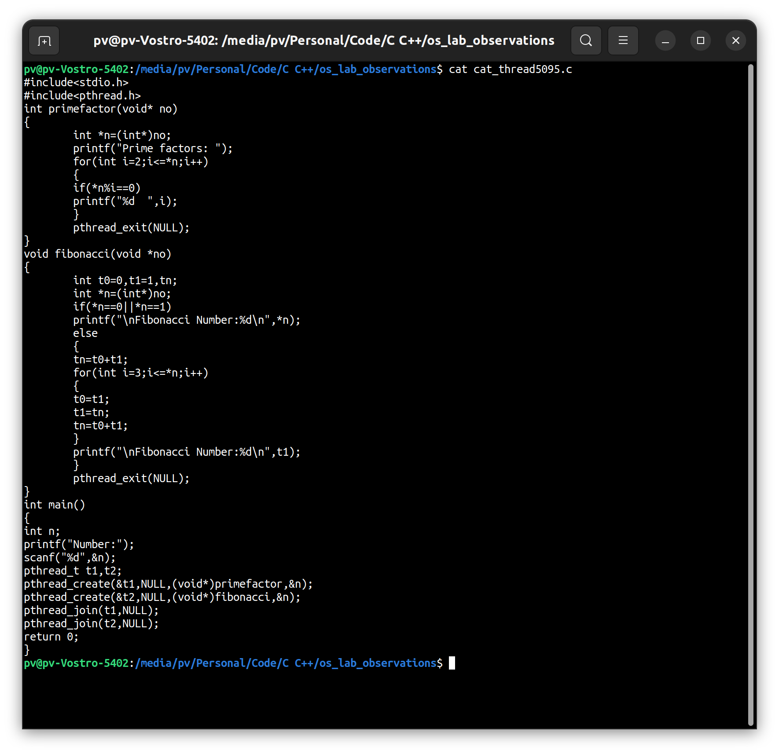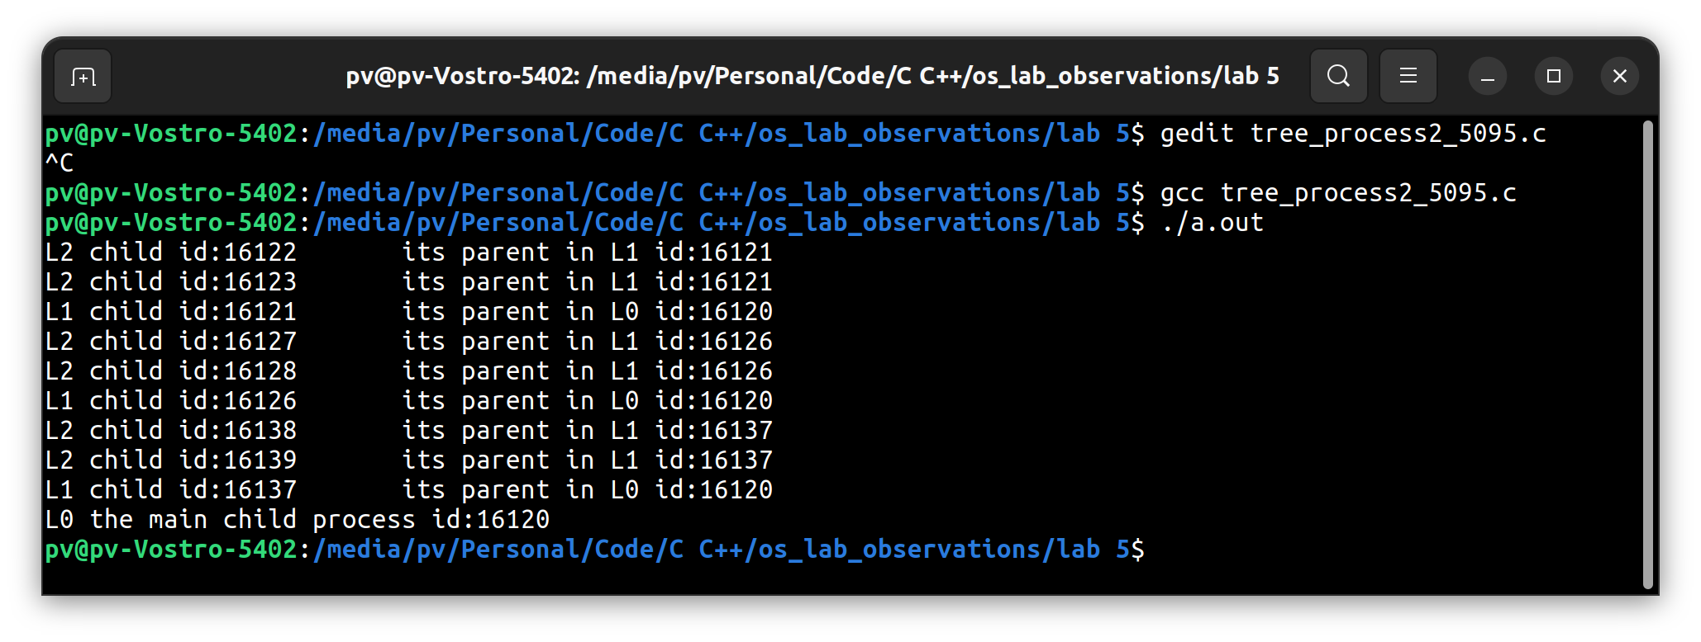 Multi thread program.

